1. **Login**

Foodpanda allows users to login using SSO through Facebook as well as via email.

**Key Features:**

* SSO Login
* Login with Email
* Login views are placed at the bottom of the screen that increases the usability when using a thumb to navigate over it.

**Issues**:

* The login activity is not validated to eliminate the unnecessary whitespace that is appended by the keyboard automatically. In android phones people often like to tap on the saved phrases that the keyboard shows as suggestions. However, doing that also puts a whitespace at the end of it as the keyboard identifies the phrase as a distinct object. In this activity the app shows an error message showing that the input is invalid.

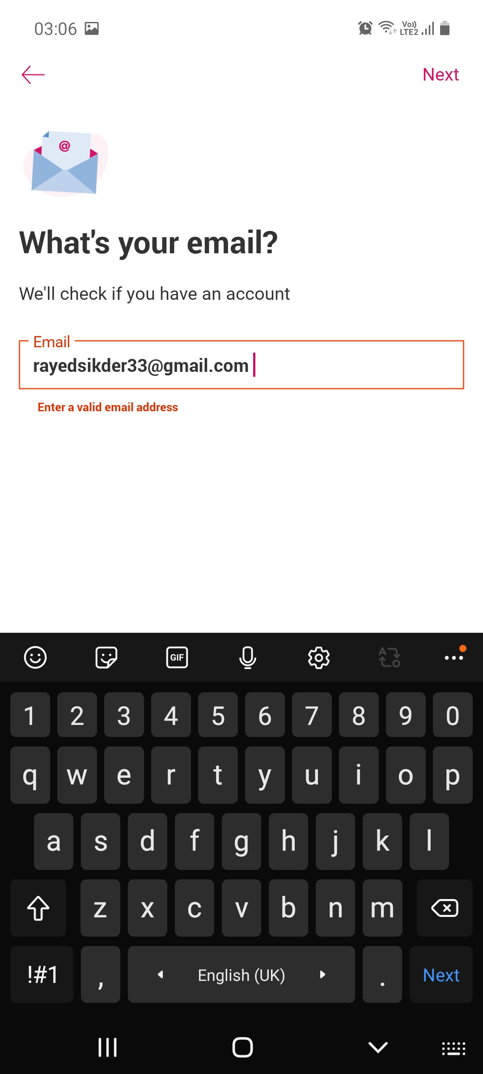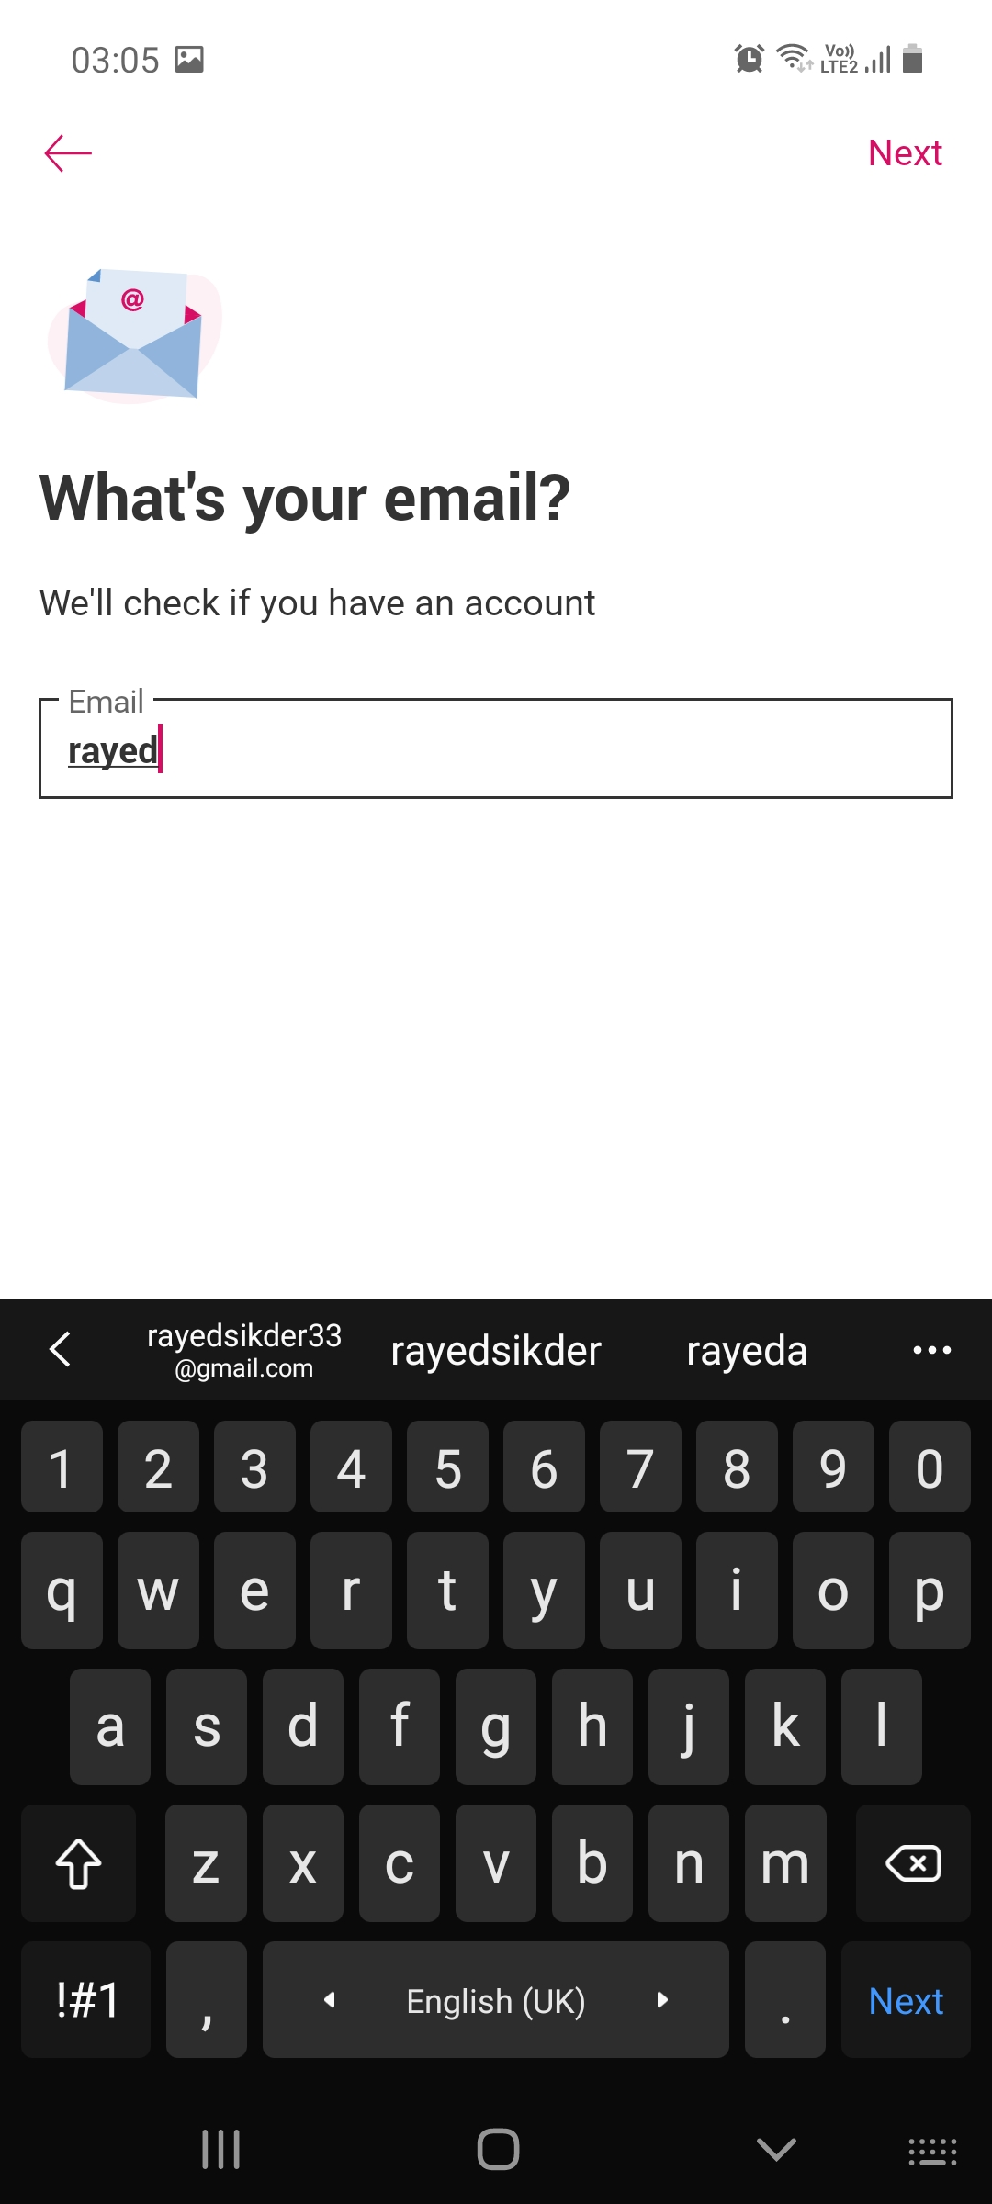

**User taps the saved email phrase**

**App shows the email as invalid when whitespace is auto appended by keyboards**

* The “Next” button after Email Login is placed at the top right which is sometimes hard to reach by thumb fingers especially with phones having bigger screens.

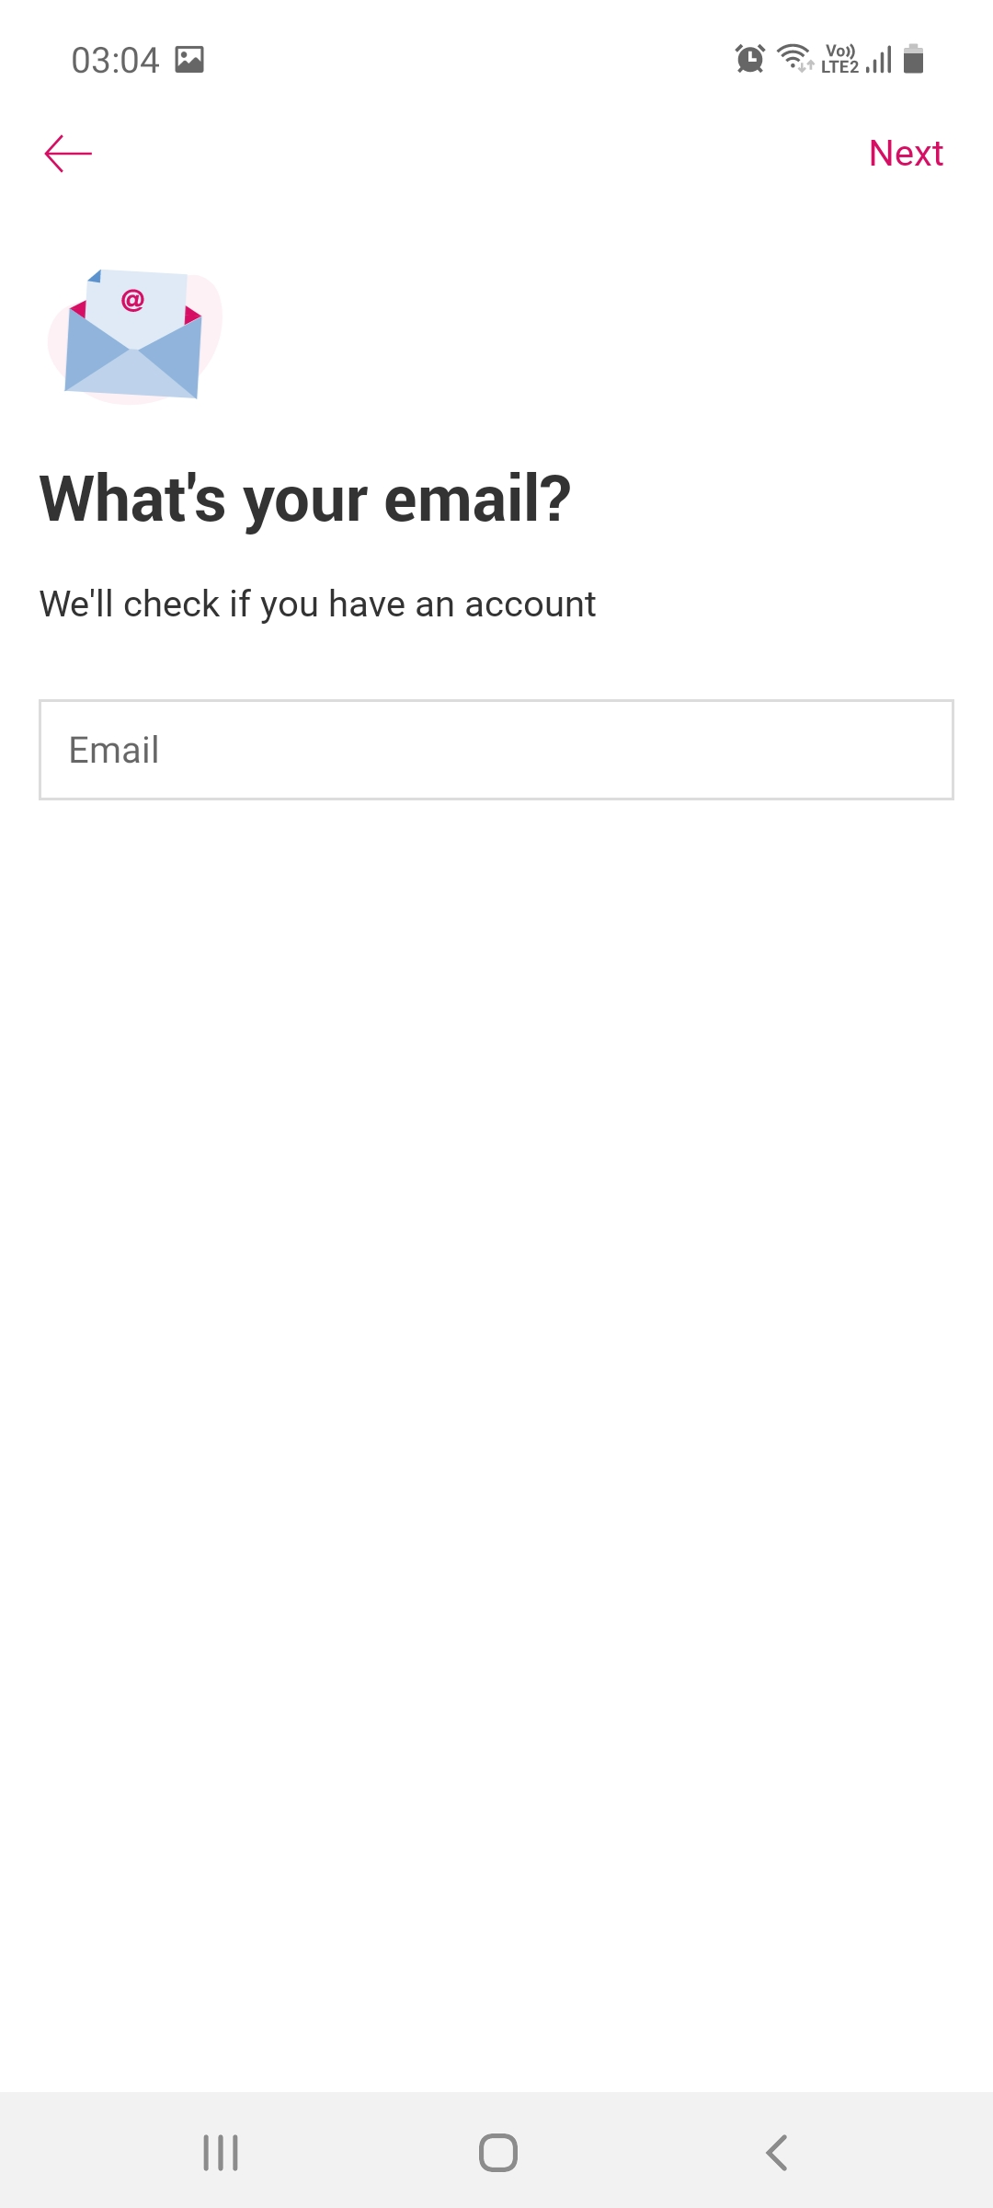

**User need to tap on to the “Email” view to open the keyboard**

**“Next” is hard to reach by thumb for large screens**

***Isn’t is obvious that if I am here, I’ll be providing my email for registration?***

***Why do I need to tap into this separately to open the keyboard!?***

1. **The dashboard**

The foodpanda dashboard is neatly designed to provide the users an easy interface to navigate within restaurants as well as check out discounts and offers.

**Key Features:**

* Flashcards on top to show offers and sale discounts
* Option to show user specified foods through custom filtering, at the top right of the search bar
* Horizontal slide options for discount and offer flashcards
* Vertical scroll for all restaurants
* Options to feature restaurants on top
* A Panda-head on the right which can be tapped to check user points that are obtained by orders.
* Delivery fee at the bottom of each restaurant icon elevates the UX as they do not need to visit the restaurant page to check out the delivery fee.

